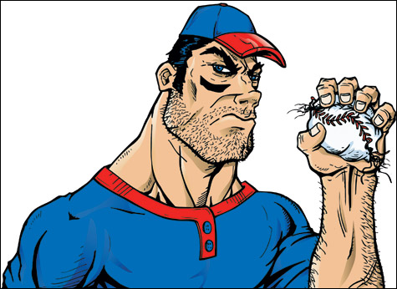
CRUSH THE BASEBALL NEXT SEASON
Are you looking for the best way to improve your son or daughter’s athletic performance? Speed, Agility and Strength training with the NTX Bulls can be the solution.
The NTX Bulls offers one of the areas only youth focused Optimum Performance Training (OPT) programs developed by the National Academy of Sports Medicine. This OPT model has been scientifically proven to be the best and safest way to train all athletes, and is currently being employed by numerous collegiate and professional sports teams.
The NTX Bulls’ integrated 50 - minute group training program is built around several core components. Each is designed to contribute to a solid athletic foundation in virtually any sport. The programs’ core components are: Active and Dynamic Stretching, Core Training, Balance Training, Plyometric Training, Speed, Agility &Quickness Training and Strength Training.
The NTX Bulls’ pricing is affordable and Team friendly: * $100 per month for the three month session (22 training sessions) November 4 – January 30. No classes the week of Thanksgiving and Christmas.
Training sessions are conducted indoors on Mondays and Wednesdays at 6:00 PM and 7:00 PM at the NTX Bulls Indoor Training Facility (The Bullpen), in North Richland Hills. (7601 Boulevard 26, North Richland Hills). Call or text Terry Wood at 817-821-1646 for more information or to get your young athlete started. Class sizes are limited to 20 athletes per session (2 sessions each training day).
Curtis Nelson’s National Academy of Sports Medicine Certifications – Youth Exercise Specialist, Performance Enhancement Specialist and Personal Trainer

